**12.Logistic Regression**

**NAME : P JAYAPRADHA**

**ROLL NO : 230701130**

import numpy as np

import pandas as pd

df=pd.read_csv('Social_Network_Ads.csv')

df

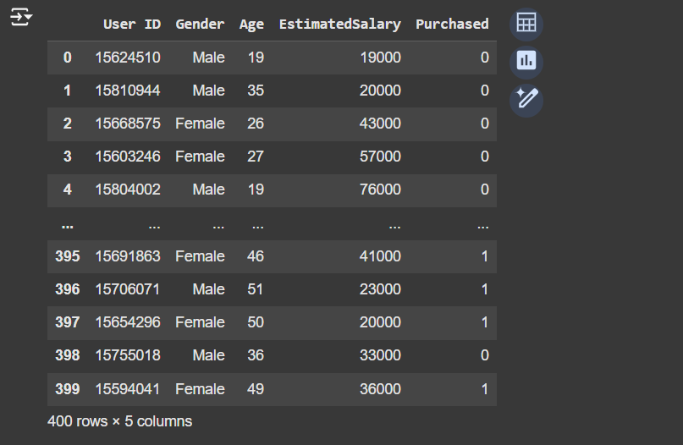

df.head()

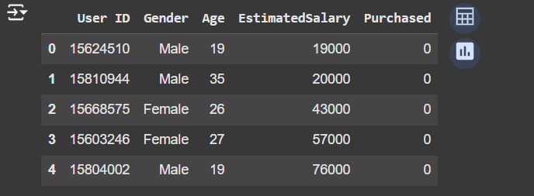

features=df.iloc[:,[2,3]].values

label=df.iloc[:,4].values

features

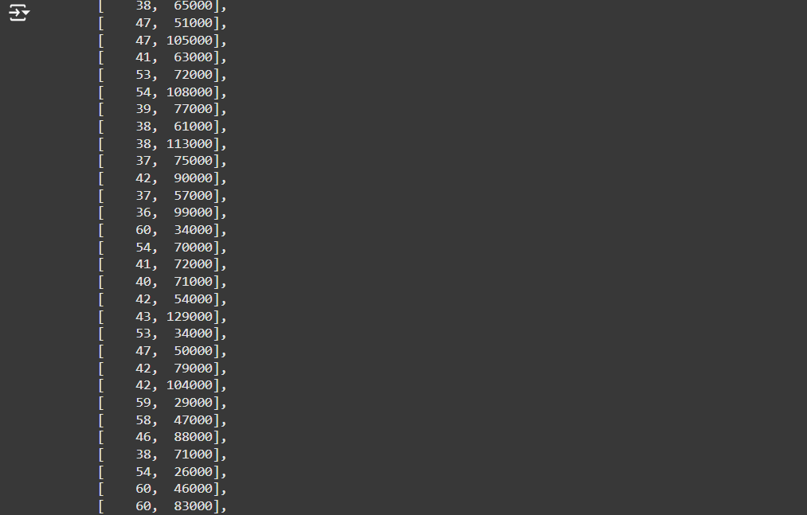

label

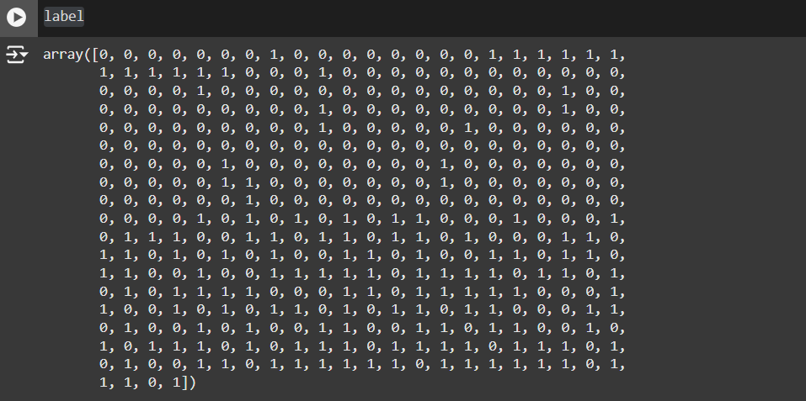

from sklearn.model_selection import train_test_split

from sklearn.linear_model import LogisticRegression

for i in range(1, 401):

    # Split the data into training and testing sets

    x_train, x_test, y_train, y_test = train_test_split(features, label, test_size=0.2, random_state=i)

    # Initialize the Logistic Regression model

    model = LogisticRegression()

    # Train the model

    model.fit(x_train, y_train)

    # Calculate the train and test scores

    train_score = model.score(x_train, y_train)

    test_score = model.score(x_test, y_test)

    # Print if test score is greater than train score

    if test_score > train_score:

        print("Test {} Train {} Random State {}".format(test_score, train_score, i))

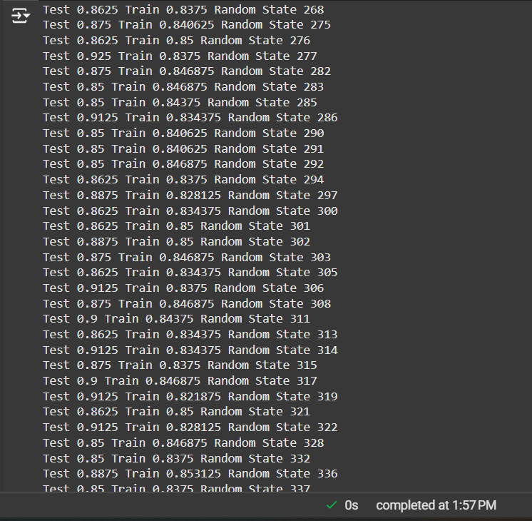

# Assuming features and label are defined earlier in your code

x_train, x_test, y_train, y_test = train_test_split(features, label, test_size=0.2)

finalModel = LogisticRegression()

finalModel.fit(x_train, y_train)

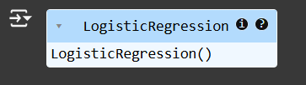

print(finalModel.score(x_train,y_train))

print(finalModel.score(x_test,y_test))

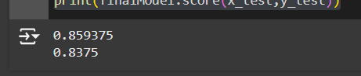

from sklearn.metrics import classification_report

print(classification_report(label,finalModel.predict(features)))

